Group 3

1. Complete the schema with the phrases below:

WWI a) _____________

c) __________________ b) _____________

___________________ Allies: d) _______

Germans:

e) ___________ f) ____________ g) __________________

____________. _______________ ____________________

Italy: h) _______________ i)_____________________ ______________________ ______________________

______________________ ______________________

First tank: British, used from September 1916 - Germans: produced a tank that was too big, so usually refitted captured British tanks - stasis situation – French: developed tank in 1916 and used it from 1917 – development of new warfare technologies - Germans: machine gun – trench war - Italy developed a tank but only in 1917; it was too heavy and with too tight tracks, and was nearly never used on the battlefield - Allies: tank

**Solution**: a) trench war – b) stasis situation – c) development of new warfare technologies – d) Allies: tank – e) Germans: machine gun – f) French: developed tank in 1916 and used it from 1917 – g) First tank: British, used from September 1916 – h) Italy developed a tank but only in 1917; it was too heavy and with too tight tracks, and was nearly never used on the battlefield) – i) Germans: produced a tank that was too big, so usually refitted captured British tanks

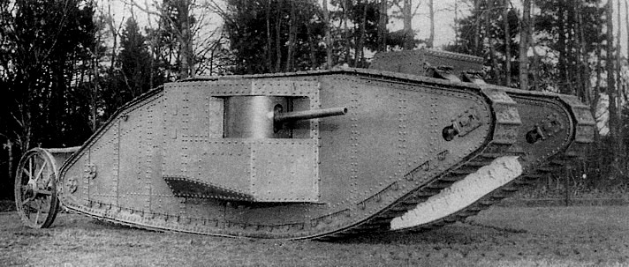

2) The tank in the picture above is *Big* Willie, the first British tank. Considering its size, why is it useful during WWI?

________________________________________________________________________________________________________________________

**Answer**: It is able to fight, to cross barbed wire, to climb a parapet and to reverse. Useful only to support infantry (too slow) and to lay cables.

3) One of the most important innovations of WWI was the development of propaganda. Match each country with the characteristics of its propaganda.

|  |  |
| --- | --- |
| 1. United Kingdom… | a. …in 1917 created a propaganda office to influence public opinion in favor of the war effort, especially with *the 4 minutes man*. |
| 2. Germany… | b. …developed the first propaganda office. |
| 3. United States…. | c. … thought the population was not smart enough to differentiate between real news and false enemy propaganda, so freedom of press was abolished. |

**Solution: 1 b 2 c 3 a**

4) Answer shortly given questions about these propaganda posters.

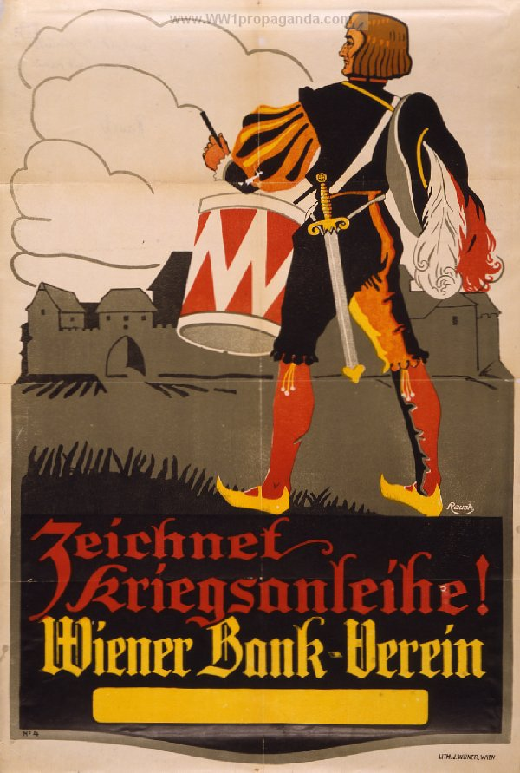

Pic. 1: “Zeichnet kriegsanleihe! Wiener Bank-Verein”, *Subscribe the War loan*.

German propaganda, 1914

Pic. 1: which type of propaganda is this, in your opinion?

front propaganda



homefront propaganda



foreign propaganda



Motivate your answer :__________________________________________________________________________________________________________________________________________________________________________________________

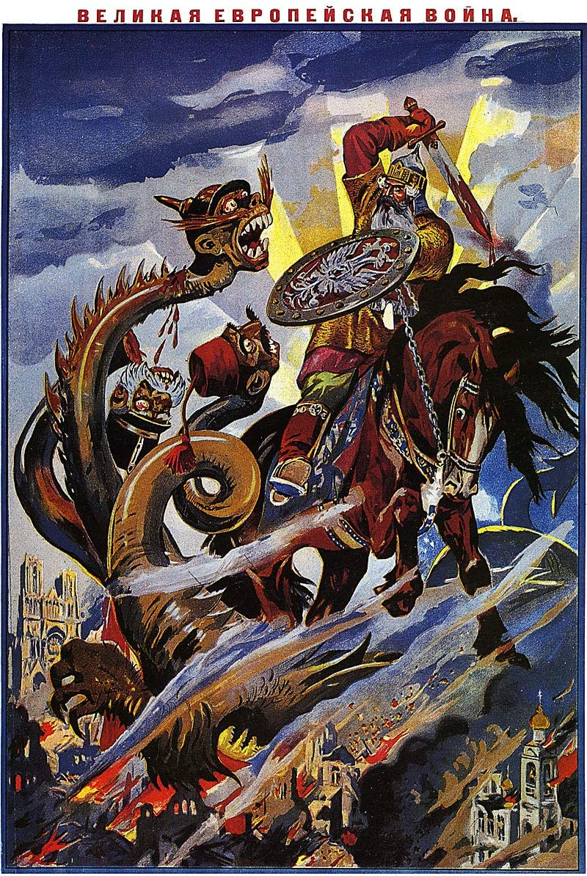

Pic. 2: a Russian propaganda poster.

How would you describe this picture? Which is its main aim? How is the enemy depicted?

_______________________________________________________________________________________________________________________________________________________________________________________________________________________________________

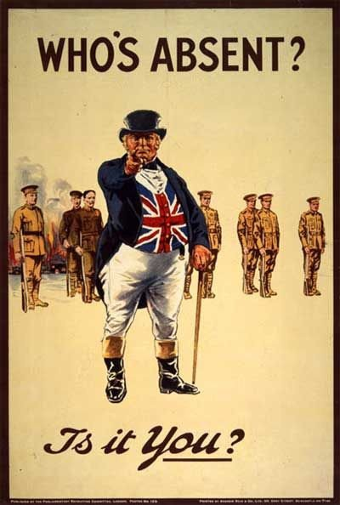

Pic. 3: a 1916 British propaganda poster.

Which is the main aim of the poster?

____________________________________________________________________________________________________________________________________________________________________________________________________________________________________________________________

Pic. 4: in this 1917 American propaganda poster the German enemy is defined as *the Hun*; why?

And how is woman depicted?

______________________________________________________________________________________________________________________________________________________________________________________________________________________________________________________________________________

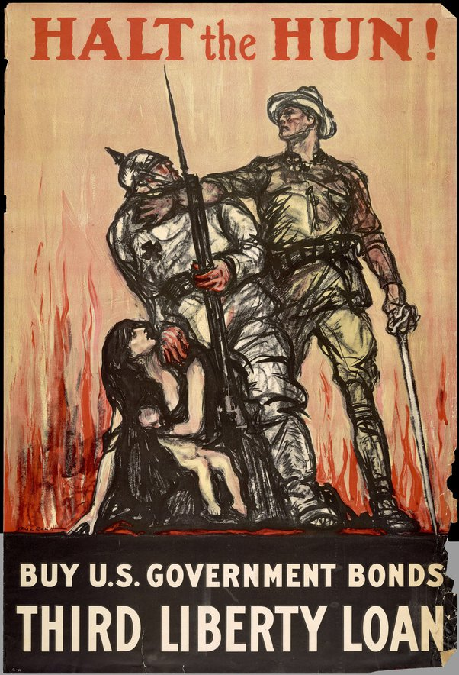

**Answer 1:** homefront propaganda to invite civilians to buy war bonds

**Answer 2**: This is a Russian propaganda poster; its main aim is todepict the enemies not as humans as Russians are, but as animals. Propaganda in this case wants to demonize and to dehumanize enemies, to create a fight between civilization and barbarity to assert a moral superiority.

**Answer 3:** homefront propaganda for British men to enlist

**Answer 4:** home front propaganda to sell US government bonds. German enemy is depicted as *the Hun*, so as a dehumanized enemy. American soldier wears a kakhi uniform and the enemy an armour: is a fight against uncivilized enemy. The liberty is gendered as a woman, who needs to be protected.

5) *Fill the gaps* with words given in this text about shell shock.

Shell shock isn’t a WWI 1)_________, but doctors didn’t understand if it was physical, mental, or if there was a 2)___________. Surely there was an 3)___________ cause: the force of artillery, that led to thousands of shell shock 4)_______. Most common 5)___________ were headache, blindness, amnesia, anxiety, depression and nightmares. This often caused a 6)__________ breakdown. Therapies were various; one of the most 7)__________ was electric shock. The problem with shell shock was that it was easy to 8)______: sometimes soldiers became 9)_________recipients without being ill.

**Words**: symptoms – fake - mental - common – pension - external - pre-disposition - cases – innovation

**Solution**: 1 innovation 2 pre-disposition 3 external 4 cases 5 symptoms 6 mental 7 common 8 fake 9 pension